**10. GitHub Repository:**

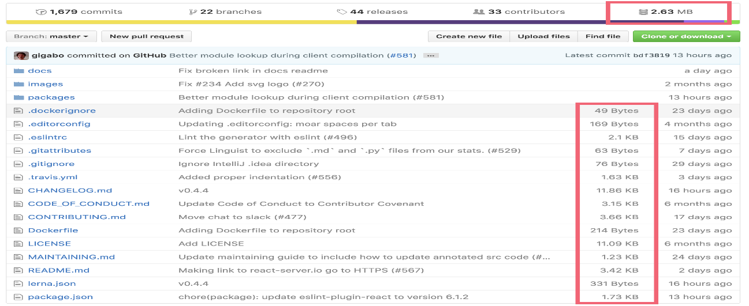To facilitate transparency and reproducibility, the authors made their source codes, experimental data, and supplementary materials available on GitHub. This repository serves as a valuable resource for other researchers and practitioners interested in sleep stage classification and the application of attention-based deep learning models in healthcare.

**Figure 3.5: GitHub Repository**